[ Insert official UPAEP logo ]
UPAEP · Decanato de Ingenierías
EVIDENCE — US06-T5
End-to-end transmission test
SmartGreenAI: Cilantro Crop

1. Task information
Task ID | US06-T5
User Story | US-06 — Transmit IoT measurements to the cloud
Sprint | Sprint 2 (2026-09-21 – 2026-10-09)
Week | Week 3
Responsible | Vicente Rocha Alfaro
Peer reviewer | Oscar Abraham Talavera Nava
Planned / actual hours | 3 h / 3 h
Completed on | October 8, 2026
Status | Done

2. Task description
Send at least 100 readings and verify that at least 95% arrive correctly in the database with the right sensor ID and timestamp. Record the average delay between reading and storage.

3. Completion conditions
✓ Condition 1: At least 100 readings were sent in the test run.
How it was verified: The simulator sent 13 cycles × 8 sensors = 104 readings (--interval 1 --count 13).
Simulator delivery report (attached: US06-T5_End-To-End_Transmission_Test_1.log)
=== Delivery report (US06-T5) ===
cycles: 13 · readings generated: 104 · accepted by the API: 104 · rejected: 0
success rate: 100.0 % · average round-trip: 119 ms · max: 137 ms
failed attempts: 0 · readings that went through the buffer: 0 · dropped (buffer full): 0 · still buffered: 0

✓ Condition 2: At least 95% arrived in the DB with correct sensor ID and timestamp.
How it was verified: 104 of 104 readings are in the database (100.0 %, target ≥ 95 %). All 104 rows carry a registered sensor ID and 104 a valid UTC recorded_at, with received_at filled by the server.
Stored readings per sensor during the test run (8 rows; US06-T5_End-To-End_Transmission_Test_2.csv)
sensor_id | readings | first_recorded | last_recorded | avg_delay_ms
CO2-01 | 13 | 2026-09-29T04:18:27.203Z | 2026-09-29T04:18:40.737Z | 83.0
HUM-01 | 13 | 2026-09-29T04:18:27.203Z | 2026-09-29T04:18:40.737Z | 53.6
LUX-01 | 13 | 2026-09-29T04:18:27.203Z | 2026-09-29T04:18:40.737Z | 65.4
PH-01 | 13 | 2026-09-29T04:18:27.203Z | 2026-09-29T04:18:40.737Z | 107.2
SM-01 | 13 | 2026-09-29T04:18:27.203Z | 2026-09-29T04:18:40.737Z | 16.1
SM-02 | 13 | 2026-09-29T04:18:27.203Z | 2026-09-29T04:18:40.737Z | 29.3
TMP-01 | 13 | 2026-09-29T04:18:27.203Z | 2026-09-29T04:18:40.737Z | 41.5
WL-01 | 13 | 2026-09-29T04:18:27.203Z | 2026-09-29T04:18:40.737Z | 94.9
SQL: SELECT m.sensor_id, COUNT(*)::int AS readings, MIN(m.recorded_at) AS first_recorded, MAX(m.recorded_at) AS last_recorded, round(AVG(EXTRACT(EPOCH FROM (m.received_at - m.recorded_at)) * 1000)::numeric, 1) AS avg_delay_ms FROM measurements m WHERE m.received_at BETWEEN $1 AND $2 AND m.recorded_at >= $1 GROUP BY m.sensor_id ORDER BY m.sensor_id
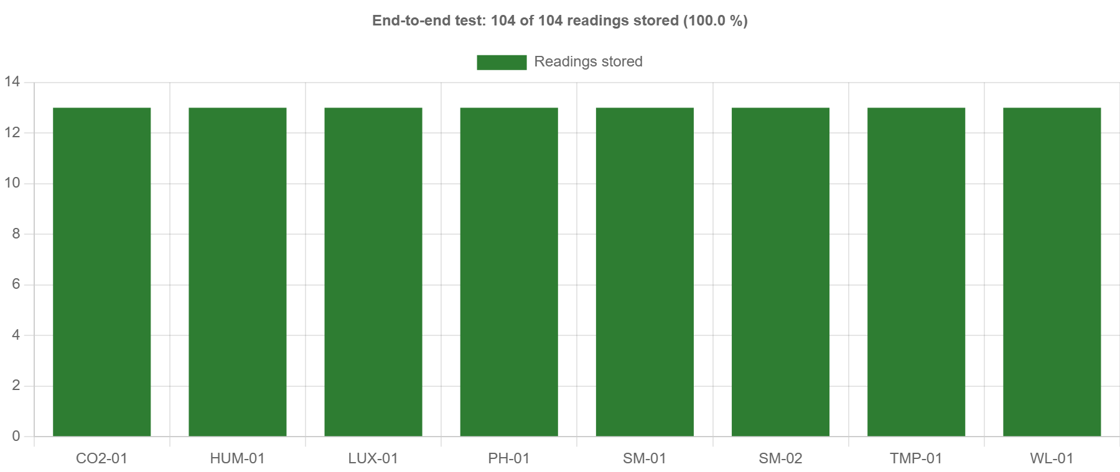
Figure US06-T5-1. Readings stored per sensor in the end-to-end transmission test. (US06-T5_End-To-End_Transmission_Test_4.png)
✓ Condition 3: Report includes success rate, average delay and logs/screenshots.
How it was verified: Report: success rate 100.0 %; average delay between reading (recorded_at) and storage (received_at) 61.4 ms, maximum 126.3 ms. The simulator log and the per-sensor query are attached.
Transmission test report
Metric | Value | Target | Result
Readings sent | 104 | ≥ 100 | PASS
Readings stored with correct sensor ID and timestamp | 104 | —
Success rate | 100.0 % | ≥ 95 % | PASS
Average delay reading → storage | 61.4 ms | reported | PASS
Maximum delay | 126.3 ms | reported | PASS
3600,1800,1800,2160
✓ Condition 4: Evidence: Test report with success rate, delay and screenshots / logs.
How it was verified: Test report with success rate, delay, chart and logs: this document and the attached files.

4. Attached files
- US06-T5_End-To-End_Transmission_Test_1.log
- US06-T5_End-To-End_Transmission_Test_2.csv
- US06-T5_End-To-End_Transmission_Test_3.sql
- US06-T5_End-To-End_Transmission_Test_4.png

5. Traceability
Related requirements | FR-05, FR-24, NFR-05, NFR-08, NFR-09
Implementation | See docs/TRACEABILITY.md
Verification | See docs/TRACEABILITY.md

6. Sign-off
Role | Name | Date | Signature
Responsible | Vicente Rocha Alfaro | October 8, 2026
Peer reviewer | Oscar Abraham Talavera Nava | October 8, 2026
Product Owner acceptance | Alexis Enrique Valle Parra | October 8, 2026

